6 May 2025

STELLA ARTOIS BECOMES OFFICIAL BEER SPONSOR OF ATP TOUR & NITTO ATP FINALS

LONDON: Today, Stella Artois, one of the world’s leading premium beer brands, announced it has become a Gold Partner and Official Beer of the ATP Tour through 2028. This multi-year global sponsorship will span some of the most prestigious events on the tennis calendar, including the Nitto ATP Finals in Turin, Italy.

As a long-time partner of several ATP tournaments, as well as being an Official Partner of Wimbledon and an Official Supplier of Roland-Garros, Stella Artois will continue its expansion within the sport. The sponsorship includes on-court brand visibility and product integration in many hospitality areas, providing the opportunity to deliver more premium “Perfect Serve” moments around the world.

Additionally, Stella Artois also becomes an Official Partner of the Nitto ATP Finals in Turin, Italy, offering premium brand visibility, hospitality, and pouring rights to enhance the fan experience during the tour finale.

This partnership reinforces AB InBev’s mega platform strategy, transforming tennis into a year-round, global activation for Stella Artois. In tennis, consistently executing the perfect serve can make the difference between victory and defeat. The same applies for Stella Artois, where the Perfect Serve pouring ritual delivers an unbeatable draught beer experience. By aligning with the ATP Tour and Nitto ATP Tour Finals, Stella Artois is well placed to deepen its connection with tennis fans and create memorable experiences throughout the season.

“Tennis continues to grow globally attracting more fans that love the sport and the premium experiences it provides. This partnership with the ATP Tour and Nitto ATP Finals allows Stella Artois to authentically be part of those fan experiences and highlight a taste worth more through the Perfect Serve program," said Marcel Marcondes, Global Chief Marketing Officer for AB InBev. “This partnership will show tennis is best served with a Stella Artois in hand.”
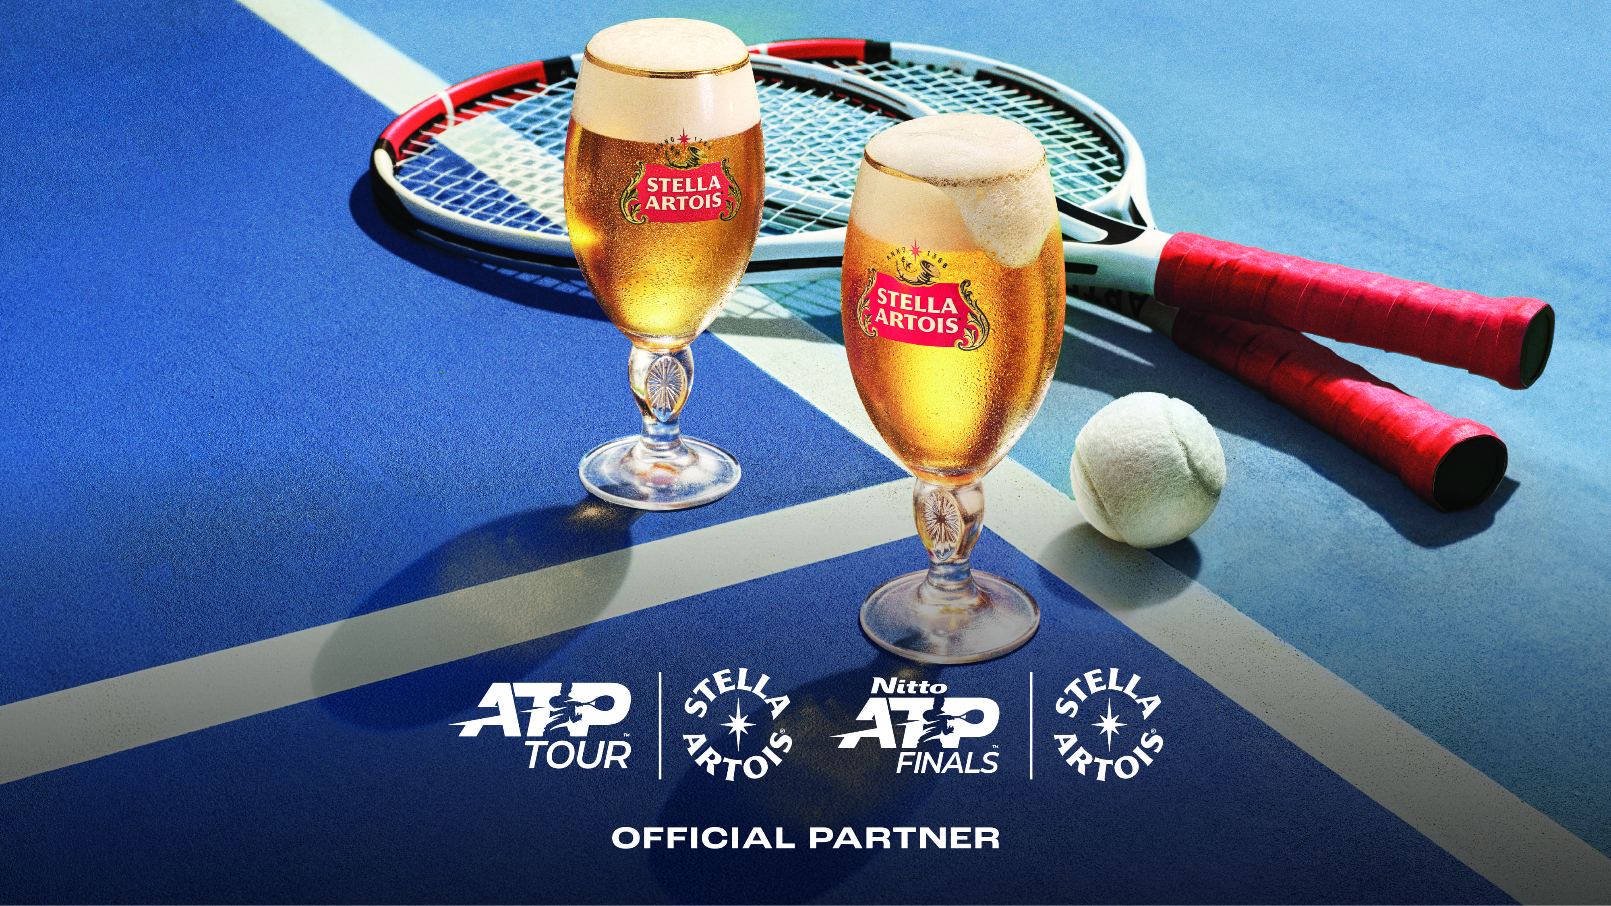

Leveraging ATP Tour’s global digital platforms, Stella Artois will launch “The Perfect Serve” content series, providing engaging online experiences for fans of legal drinking age. This series will allow fans to vote for the player with the best serve each month, promoted across ATP Tour and Stella Artois social channels.
Additionally, Stella Artois will partner with the ATP No. 1 Club, uniting current, former, and future ATP World No. 1 players, with exclusive activations planned for the 2025 Nitto ATP Finals.

“Stella Artois is not only one of the world’s most iconic beer brands; it’s a brand that truly understands our sport – not just as a game, but as an experience,” said Daniele Sanó, ATP Chief Business Officer. “With a rich history in tennis, they’ve created unforgettable moments for our fans across generations. We’re proud to be a part of their legacy and excited to keep building on this, finding new ways to bring even more entertainment to the game.”

# # #

Media contact: communications@atptour.com

About The ATP
The ATP’s mission is to serve tennis. As governing body of the ATP Tour and Challenger Tour we entertain a billion global fans, showcase the world’s greatest players at prestigious tournaments, and inspire the game’s next generation. From the United Cup in Australia, to Europe, the Americas and Asia, the stars of the game battle for titles and PIF ATP Rankings points at ATP Masters 1000, 500 and 250 events, and Grand Slams. All roads lead to the Nitto ATP Finals, our prestigious season finale held in Turin, Italy. Featuring only the season’s best 8 singles players and doubles teams, the tournament sees the crowning of the year-end ATP World No. 1, presented by PIF, the ultimate achievement in tennis. For more information, please visit www.ATPTour.com.

